Part one
Pictures of the two scenes
Scene one: (A woman is lighting a cigarette. A man sidles up next to her and begins talking.)
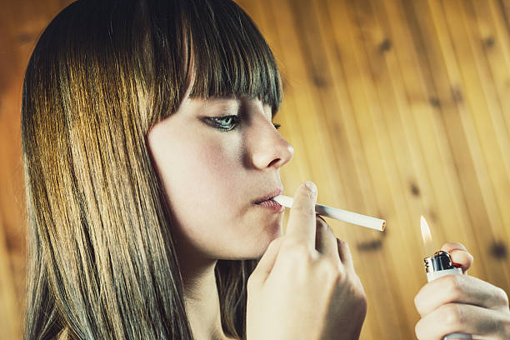
The place
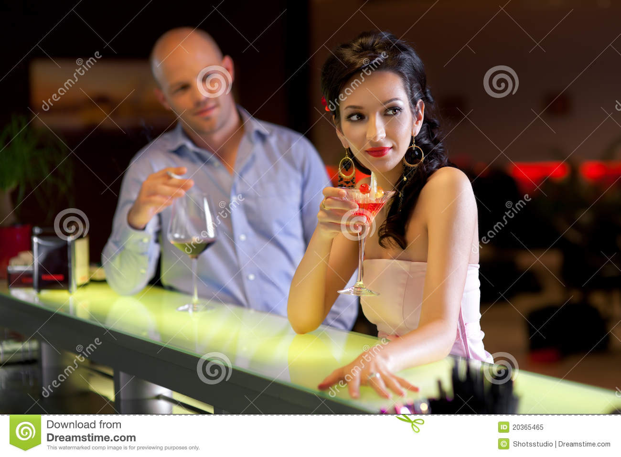

Architecture,
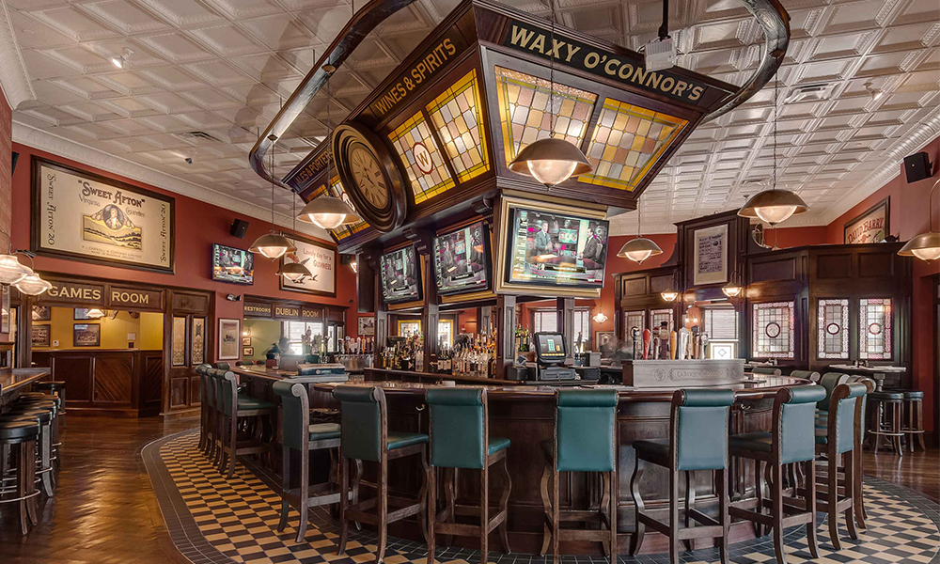

Things that give the play a time and place in real world
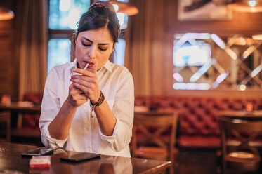

Scene Two; (Lights up on a room. There is only a bed and a night stand with a lamp.)
The place



Architecture
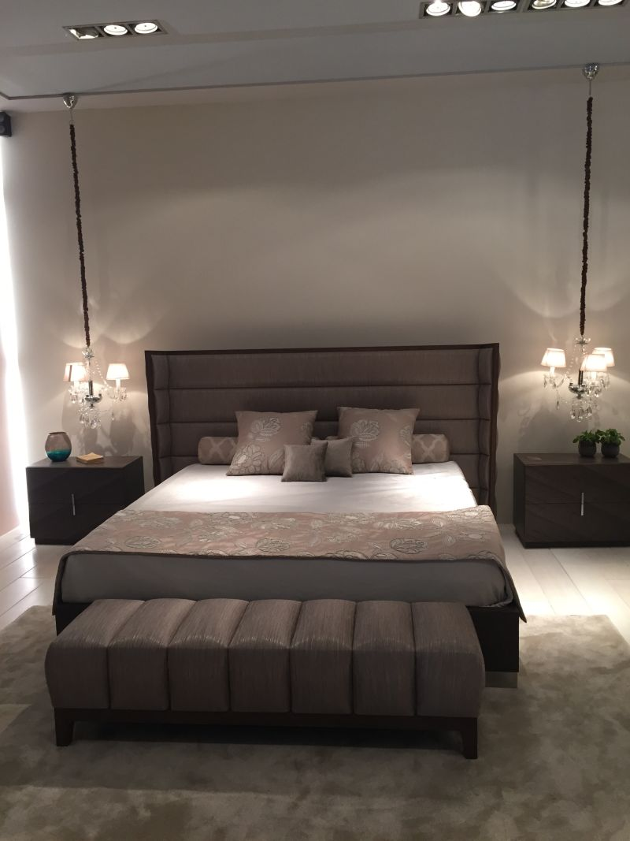

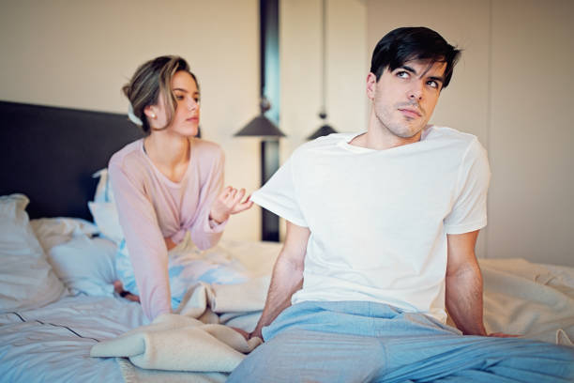
Things that give the play a time and place in real world


Sketch a ground plan
Scene One
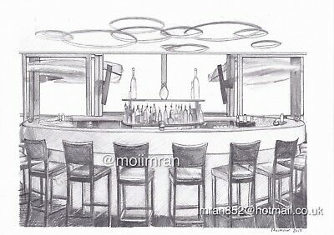
Scene Two
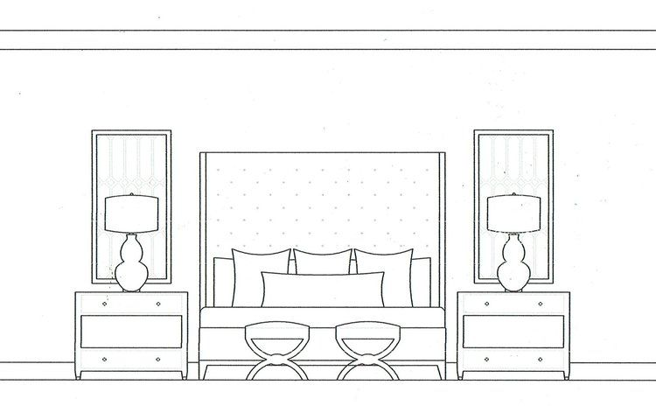

Rationale for the scenic choices
Scene one
Scene one is set up in a open bar where a lady is lighting a cigarette which prompted me to find an image for a lady lighting a cigarette. The second picture is a man and a woman sitting side by side which is depicted in the beginning of scene one when a man slides and sits next to the lady smoking and starts a conversation. The place images are used to portray the directions given at the begging on how the play is set. The architecture is based on the setting of the play at a bar where prostitutes wait for clients to sport them especially at the counter. At the things that give the play a time and place in the real world, I choose a woman sitting alone in a table at a bar (probably waiting for company). The woman is Jacqueline who is waiting for a man to spot her. In the second picture, I choose an open bar setting with people chatting. These symbolizes the nature of the area in which Jacqueline was and the events that happened after John joined her. The people in the picture are having a chat especially the lady and the man who I presume to Jacqueline and john as they talk.
Scene two
The woman and man in a bed with a lamp on a stand signify the place set for the play, lights up on a room, a bed only and a night stand with a lamp. The architecture is that of a room with lights on it, a bed only and the lamps on a night stands. A perfect fit for our scene two which is held in such a setting. The architecture tries to bring out the simplicity of the play setting as defined at the beginning of scene two. The things that give the play a time and place in the real world are the t-shirt Jacqueline is asked to put on and the two strangers having a personal yet intimate conversation. The image of the woman and man on a bed having a rather awkward time is significant of the heated environment between John and Jacqueline. Although they want each other’s company for different reasons, they are still undecided if they are ready to accommodate each other. The lady on the other picture is Jacqueline who has put on a t shirt as requested by John. She is feeling unease because she is not used to such encounters in her line of work making her unsure of whether to stay or leave.

